
Foraging Task

In the following, you will have the opportunity to get to know and practice one of the tasks that you will later perform in the MRI scanner.
Please read all of the following instructions carefully. It takes some time, but otherwise you will not know what to do!

In this game, you are the captain of a spaceship travelling through space. Unfortunately, there is a problem: you are running dangerously low on fuel…By chance, you have entered an area of space which is home to a community of space aliens like the ones below.



If you catch these aliens, they will provide you with different amounts of fuel. But they also take different amounts of time to catch. You need to decide which aliens you want to catch when you see them in order to get as much fuel as you can from your time here. The aliens can be found in three different galaxies, all of which you will journey through. Some types of aliens are more commonly found in one galaxy than the other.

During the game, two targets will appear on the screen as you travel; one on the left and one on the right. Different aliens will quickly come towards either one of these targets:

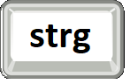

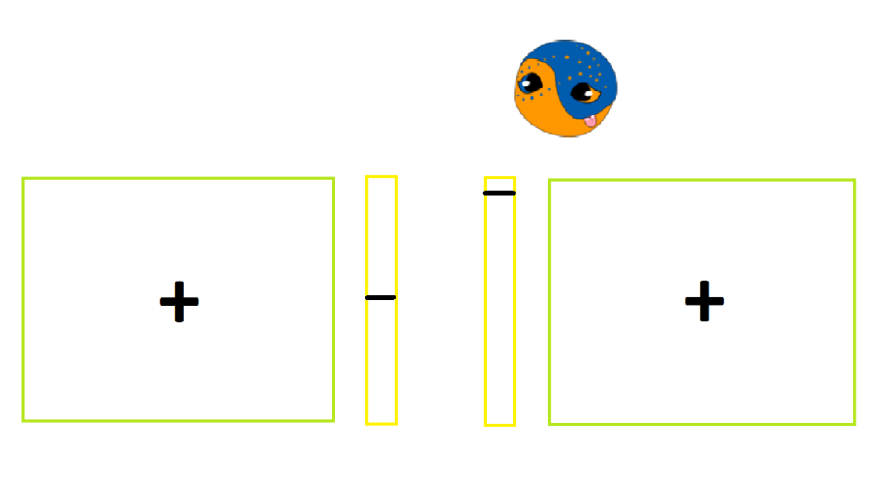



If you want to catch an approaching alien, you need to do two things:

- Select the target it approaches – if you wait until the alien is actually inside the target this is too late! Select the left target by pressing the left “ctrl” (on german keyboard: strg) key and the right target by pressing the right “ctrl” key on your computer keyboard. The target will jump into the target to indicate it is selected.
- Keep the key pressed down and the alien will get bigger.

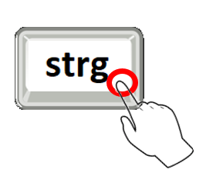
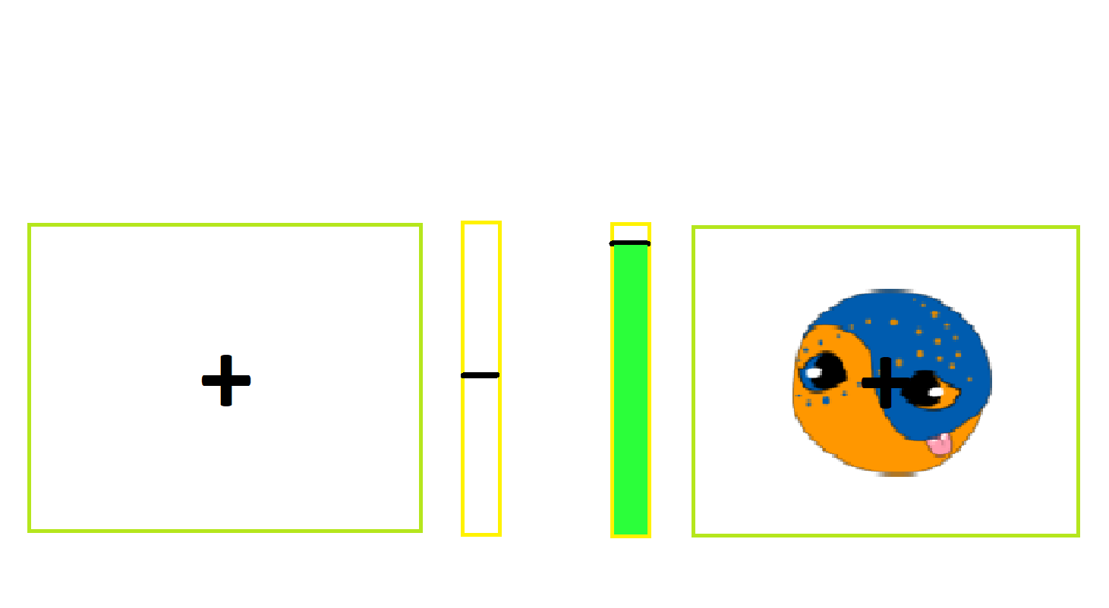


When you have successfully captured the alien, the alien will stop getting bigger and you will see how much fuel the alien has provided you with. Also note that aliens appear quickly - you need to be fast to make a choice!

Some types of aliens are better than others. Some aliens are quick to capture and give you a lot of fuel. Other aliens take a long time to capture and do not provide you with much fuel.

To let an alien pass rather than catch it you need to select the target that the alien is not approaching. There is no need to keep the key pressed down. Simply press they key once to select the target and then release the key. The alien will then safely pass through the opposite target without being caught and the game will continue.





In the example above, to avoid the approaching alien, you should select the left target (i.e. the target it is not coming towards) by pressing the which one key once. There is no need to continue to keep the key pressed down. The alien will pass through the opposite target without being caught. You won't collect any fuel but you will not use up any time in the game trying to capture it and the game will continue. Once you have decided to avoid an alien, you cannot change your mind.

As you might have noticed, missed responses can occur. When this happens the size of the alien reduces again and nothing is happening anymore. In that case you are not getting any fuel and you have to wait until the alien disappears by itself which takes time. A missed response will occur for the following reasons:

(1) If you fail to select either one of the two targets when an alien is approaching (remember it is fine if you prefer not to catch an alien, but to do this you need to select the target it is not approaching).

(2) If you try to catch an alien but select the target after the alien has reached the target.

(3) If you start trying to catch an alien but release the key too early (i.e. before it is successfully captured).

You will perform the task you have learned here later in the MRI in three passes. Instead of buttons, you will be able to make your selection using handles. You will be able to practice the task in the MRI with the handles again before the actual task starts. All the fuel you collect will be later translated into money for you to win!

